Health Knowledge
Activity or Task: ________________________________________Content area: ____________________
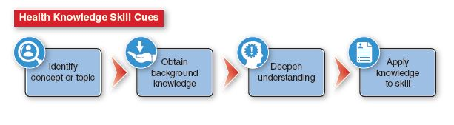
Rating |  | Description
Above Mastery | 4 | Identifies concept or topic, obtained an excellent quality and quantity of relevant and accurate background knowledge, and significantly deepened understanding of the identified content. Demonstrates the ability to apply the knowledge in one or more health skills.
Mastery | 3 | Identifies concept or topic, obtained appropriate, relevant and accurate background knowledge, and deepened understanding of the identified content. Demonstrates the ability to apply the knowledge in one or more health skills.
Approaching Mastery | 2 | Identifies concept or topic, obtained some background knowledge, and showed limited growth in understanding. Struggled to apply the knowledge in a health skill.
Novice | 1 | No content was identified, or the information is inappropriate to the task. Quality of the information may be poor and/or student is unable to accurately connect the information to a health skill.

Score: _________________
Comments:

Analyzing Influences
Activity or Task: _______________________________________________________________________
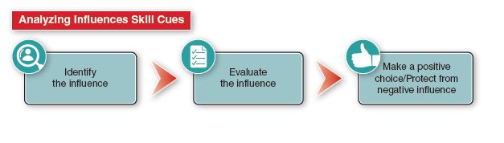
Rating |  | Description
Above Mastery | 4 | Fully identifies internal and external influences. Accurately and completely evaluates how the influence impacts them. Able to identify strategies to engage a positive influence and protect from a negative influence.
Mastery | 3 | Identifies relevant internal and external influences. Effectively evaluates how the influence impacts them. Able to choose the positive influence. Attempts to protect from negative influences exist but may not be fully developed.
Approaching Mastery | 2 | Identifies most internal and external influences. Does not effectively evaluate or explain the influence. The ability to make a positive choice or protect themself from a negative influence is not fully developed.
Novice | 1 | Unable to identify relevant influences. Cannot fully decipher the impact of the influence or make appropriate choices as a result.

Score: _____________
Comments:

Analyzing Influences + Health Knowledge
Activity or Task: ____________________________________ Content area: _______________________
Skill Cue: Analyzing Influences
Rating |  | Description | Rating |  | Description
Above Mastery | 4 | Identifies and utilized ample, accurate and specific background information and could clearly, accurately and appropriately connected the content to all aspects of the skill cue. | Above Mastery | 4 | Fully identifies internal and external influences. Accurately and completely evaluates how the influence impacts them. Able to identify strategies to engage a positive influence and protect from a negative influence.
Mastery | 3 | Identifies and utilized sufficient background information and could clearly, accurately and appropriately connect content to all aspects of the skill cue. | Mastery | 3 | Identifies relevant internal and external influences. Effectively evaluates how the influence impacts them. Able to choose the positive influence. Attempts to protect from negative influences exist but may not be fully developed.
Approaching Mastery | 2 | Identifies and utilized general background information. Student was unable to accurately connect the content to all aspects of the skill cue. | Approaching Mastery | 2 | Identifies most internal and external influences. Does not effectively evaluate or explain the influence. The ability to make a positive choice or protect themself from a negative influence is not fully developed.
Novice | 1 | Identifies, or the information is inappropriate to the task. Quality of the information may be poor and/or student is unable to accurately connect the information to the skill cue. | Novice | 1 | Unable to identify relevant influences. Cannot fully decipher the impact of the influence or make appropriate choices as a result.
Score: _______________
Comments:

Accessing Valid and Reliable Information
Activity or Task: _______________________________________________________________________
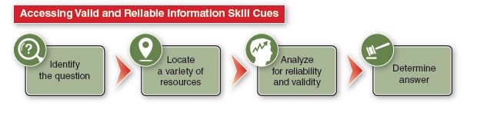
Rating |  | Description
Above Mastery | 4 | The question or issue was accurately and appropriately identified a variety of appropriate and quality resources were utilized. All information was appropriately analyzed for reliability and validity and the question or issue was accurately and thoroughly addressed.
Mastery | 3 | The question or issue was accurately and appropriately identified, and a variety of appropriate and quality resources were utilized. Most of the information was appropriately analyzed for reliability and validity and the question or issue was accurately addressed.
Approaching Mastery | 2 | The question or issue was accurately identified, and a variety of sources were utilized. Analysis of information for reliability and validity was inconsistent with some errors present and the question or issue was not fully addressed.
Novice | 1 | There was difficulty in addressing the question or task and no sources were located or the information was inappropriate to the task. Quality of the source may be poor and/or student is unable to accurately evaluate the information.
Score: _________
Comments:

Accessing Valid and Reliable Information + Health Knowledge
Activity or Task: ______________________________________ Content area: _____________________
Skill Cues: Accessing Valid and Reliable Health Information
Rating |  | Content Knowledge Description | Rating |  | Accessing Valid and Reliable Information Description
Above Mastery | 4 | Identifies and utilizes ample, accurate and specific information and could clearly, accurately and appropriately connect the content to all aspects of the skill cue. | Above Mastery | 4 | The question or issue was accurately and appropriately identified a variety of appropriate and quality resources were utilized. All information was appropriately analyzed for reliability and validity and the question or issue was accurately and thoroughly addressed
Mastery | 3 | Identifies and utilized sufficient information and could clearly, accurately and appropriately connect content to all aspects of the skill cue. | Mastery | 3 | The question or issue was accurately and appropriately identified, and a variety of appropriate and quality resources were utilized. Most of the information was appropriately analyzed for reliability and validity and the question or issue was accurately addressed.
Approaching Mastery | 2 | Identifies and utilized general information but Sources may be inaccurate or flawed. Student was unable to accurately connect the content to all aspects of the skill cue. | Approaching Mastery | 2 | The question or issue was accurately identified, and a variety of sources were utilized. Analysis of information for reliability and validity was inconsistent with some errors present and the question or issue was not fully addressed.
Novice | 1 | No content was identified, or the information is inappropriate to the task. Quality of the information may be poor and/or student is unable to accurately connect the information to the skill cue. | Novice | 1 | There was difficulty in addressing the question or task and no sources were located or the information was inappropriate to the task. Quality of the source may be poor and/or student is unable to accurately evaluate the information.
Score: _________
Comments:

Accessing Valid and Reliable Web Information
Activity or Task: _______________________________________________________________________
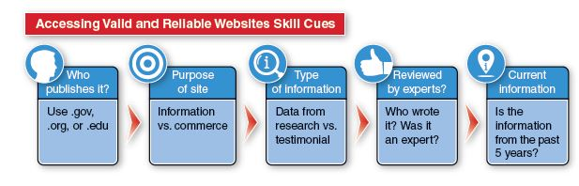
Rating |  | Description
Above Mastery | 4 | All sites used were .gov, .org or .edu, were information-based sites, used research not testimonials, were written or reviewed by content experts and were current within 5 years.
Mastery | 3 | Most sites (over 50%) used were .gov, .org or .edu, were information-based sites, used research not testimonials, were written or reviewed by content experts and were current within 5 years.
Approaching Mastery | 2 | Half, or less than half of sites used were .gov, .org or .edu, were information-based sites, used research not testimonials, were written or reviewed by content experts and were current within 5 years.
Novice | 1 | None of the sites used met the skill cue criteria.

Score: __________________
Comments:

Accessing Valid and Reliable Web Information + Health Knowledge
Activity or Task: ______________________________________ Content area: _____________________
Skill Cues: Accessing Valid and Reliable Web Information
Rating |  | Content Knowledge Description | Rating |  | Accessing Valid and Reliable Web Information Description
Above Mastery | 4 | Identifies and utilizes ample, accurate and specific information and could clearly, accurately and appropriately connect the content to all aspects of the skill cue. | Above Mastery | 4 | An appropriate site was used the met all of the following criteria: gov, .org., .edu; factual, non-commerce; research, not testimonial; written or reviewed by content expert and recent (within five years)  All information was appropriately analyzed for reliability and validity and the question or issue was accurately and thoroughly addressed.
Mastery | 3 | Identifies and utilized sufficient information and could clearly, accurately and appropriately connect content to all aspects of the skill cue. | Mastery | 3 | An appropriate site was used the met most of the following criteria: gov, .org., .edu; factual, non-commerce; research, not testimonial; written or reviewed by content expert and recent (within five years)  All information was appropriately analyzed for reliability and validity and the question or issue was accurately and thoroughly addressed.
Approaching Mastery | 2 | Identifies and utilized general information but Sources may be inaccurate or flawed. Student was unable to accurately connect the content to all aspects of the skill cue. | Approaching Mastery | 2 | A site was used the met some of the following criteria: gov, .org., .edu; factual, non-commerce; research, not testimonial; written or reviewed by content expert and recent (within five years)  Information was not fully analyzed for reliability and validity and the question or issue was not accurately and thoroughly addressed.
(continued on next page)

Accessing Valid and Reliable Web Information + Health Knowledge
Rating |  | Content Knowledge Description | Rating |  | Accessing Valid and Reliable Web Information Description
Novice | 1 | No content was identified, or the information is inappropriate to the task. Quality of the information may be poor and/or student is unable to accurately connect the information to the skill cue. | Novice | 1 | No sources are located or sources are of poor quality. The information is inappropriate to the task and the student is unable to accurately evaluate the information or address the question or issue.

Score: __________________
Comments:

Healthy Communication
Activity or Task: _______________________________________________________________________
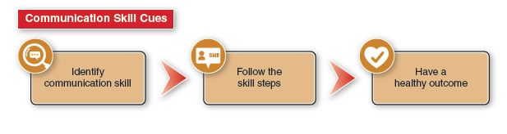
Rating |  | Description
Above Mastery | 4 | Successfully identifies the skill needed (e.g. refusal skills, active listening, conflict resolution, assertiveness, negotiation, I-messages) and is able to follow all of the skills steps appropriately. The effective use of communication resulted in a healthy outcome.
Mastery | 3 | Successfully identifies the skill needed (e.g. refusal skills, active listening, conflict resolution, assertiveness, negotiation, I-messages) and is able to follow most of the skills steps appropriately. The effective use of communication resulted in a healthy outcome.
Approaching Mastery | 2 | Successfully identifies the skill needed (e.g. refusal skills, active listening, conflict resolution, assertiveness, negotiation, I-messages) but missed enough steps in executing the skill that overall communication was compromised, and the outcome was not as healthy as could be.
Novice | 1 | Failed to identify or use an appropriate communication skill and did not experience a healthy outcome.

Score: _______________
Comments:

Making Healthy Decisions
Activity or Task: _______________________________________________________________________
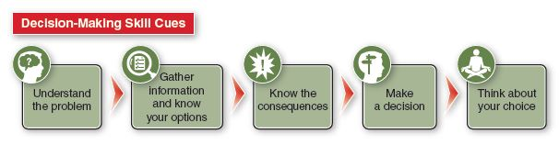
Rating |  | Description
Above Mastery | 4 | A healthy decision was reached using a full decision-making process. A clear understanding of the problem is given. Accurate and adequate information was used to identify appropriate options and clear and comprehensive consequences were identified. The student was able to reflect on the decision.
Mastery | 3 | A healthy decision was reached. A clear understanding of the problem was given but the quality or quantity of information was lacking, and consequences were identified but were not comprehensive.
Approaching Mastery | 2 | Student reaches a health enhancing decision. The decision-making process is incomplete. The reason for the final decision may be vague or misaligned with previous steps in the process.
Novice | 1 | Does not reach a health enhancing decision and/or the steps of the decision-making process are not evident.

Score: _______________
Comments:

Making Healthy Decisions + Health Knowledge
Activity or Task: ______________________________________ Content area: _____________________
Rating |  | Content Knowledge Description | Rating |  | Making Healthy Decisions Description
Above Mastery | 4 | Identifies and utilizes ample, accurate and specific information and could clearly, accurately and appropriately connect the content to all aspects of the skill cue. | Above Mastery | 4 | A healthy decision was reached using a full decision-making process. A clear understanding of the problem is given. Accurate and adequate information was used to identify appropriate options and clear and comprehensive consequences were identified. The student was able to reflect on the decision.
Mastery | 3 | Identifies and utilized sufficient information and could clearly, accurately and appropriately connect content to all aspects of the skill cue. | Mastery | 3 | A healthy decision was reached. A clear understanding of the problem was given but the quality or quantity of information was lacking, and consequences were identified but were not comprehensive.
Approaching Mastery | 2 | Identifies and utilized general information but Sources may be inaccurate or flawed. Student was unable to accurately connect the content to all aspects of the skill cue. | Approaching Mastery | 2 | Student reaches a health enhancing decision. The decision-making process is incomplete. The reason for the final decision may be vague or misaligned with previous steps in the process.
Novice | 1 | No content was identified, or the information is inappropriate to the task. Quality of the information may be poor and/or student is unable to accurately connect the information to the skill cue. | Novice | 1 | Does not reach a health enhancing decision and/or the steps of the decision-making process are not evident.
Score: _______________
Comments:

Setting Healthy Goals
Activity or Task: ______________________________________ Content area: _____________________
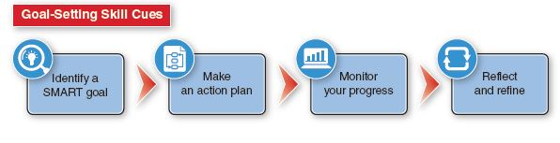
Rating |  | Description
Above Mastery | 4 | The goal is specific regarding student actions, measurable so that progress can be determined, is achievable for the student, is realistic and makes sense for the student and circumstance and has appropriate time frames attached.
Mastery | 3 | All elements of the SMART skill cue are present but one of the elements is lacking in quality or precision.
Approaching Mastery | 2 | A goal is written but one or more elements of the SMART skill cue is missing, or multiple elements are lacking in quality or precision.
Novice | 1 | No goal is written or the goal is not specific, measurable, achievable, realistic or timely.

Score: _______________
Comments:

Setting Healthy Goals + Health Knowledge
Activity or Task: ______________________________________ Content area: _____________________
Rating |  | Content Knowledge Description | Rating |  | Setting SMART Goals Description
Above Mastery | 4 | Identifies and utilizes ample, accurate and specific information and could clearly, accurately and appropriately connect the content to all aspects of the skill cue. | Above Mastery | 4 | The goal is specific regarding student actions, measurable so that progress can be determined, is achievable for the student, is realistic and makes sense for the student and circumstance and has appropriate time frames attached.
Mastery | 3 | Identifies and utilized sufficient information and could clearly, accurately and appropriately connect content to all aspects of the skill cue. | Mastery | 3 | All elements of the SMART skill cue are present but one of the elements is lacking in quality or precision.
Approaching Mastery | 2 | Identifies and utilized general information but Sources may be inaccurate or flawed. Student was unable to accurately connect the content to all aspects of the skill cue. | Approaching Mastery | 2 | A goal is written but one or more elements of the SMART skill cue is missing, or multiple elements are lacking in quality or precision.
Novice | 1 | No content was identified, or the information is inappropriate to the task. Quality of the information may be poor and/or student is unable to accurately connect the information to the skill cue. | Novice | 1 | No goal is written, or the goal is not specific, measurable, achievable, realistic or timely.

Score: _______________
Comments:

Practicing Healthy Behaviors
Activity or Task: ______________________________________ Content area: _____________________
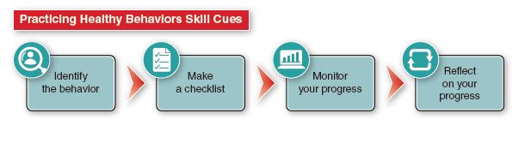
Rating |  | Description
Above Mastery | 4 | Student clearly and thoughtfully identifies an appropriate healthy behavior, creates or locates an accurate and usable checklist or log, regularly and thoroughly monitors progress using that checklist, and thoughtfully reflects on progress made.
Mastery | 3 | Student identifies an appropriate healthy behavior, creates or locates an appropriate checklist, regularly monitors progress and reflects on progress made.
Approaching Mastery | 2 | Student identifies an appropriate healthy behavior but fails to utilize an appropriate checklist or log or does not reflect accurately on progress.
Novice | 1 | Student fails to identify an appropriate behavior or to monitor that behavior in order to reflect on progress.

Score: _______________
Comments:

Practicing Healthy Behaviors + Health Knowledge
Activity or Task: ______________________________________ Content area: _____________________
Rating |  | Content Knowledge Description | Rating |  | Practicing Healthy Behaviors Description
Above Mastery | 4 | Identifies and utilizes ample, accurate and specific information and could clearly, accurately and appropriately connect the content to all aspects of the skill cue. | Above Mastery | 4 | Student clearly and thoughtfully identifies an appropriate healthy behavior, creates or locates an accurate and usable checklist or log, regularly and thoroughly monitors progress using that checklist, and thoughtfully reflects on progress made.
Mastery | 3 | Identifies and utilized sufficient information and could clearly, accurately and appropriately connect content to all aspects of the skill cue. | Mastery | 3 | Student identifies an appropriate healthy behavior, creates or locates an appropriate checklist, regularly monitors progress and reflects on progress made.
Approaching Mastery | 2 | Identifies and utilized general information but Sources may be inaccurate or flawed. Student was unable to accurately connect the content to all aspects of the skill cue. | Approaching Mastery | 2 | Student identifies an appropriate healthy behavior but fails to utilize an appropriate checklist or log or does not reflect accurately on progress.
Novice | 1 | No content was identified, or the information is inappropriate to the task. Quality of the information may be poor and/or student is unable to accurately connect the information to the skill cue. | Novice | 1 | Student fails to identify an appropriate behavior or to monitor that behavior in order to reflect on progress.
Score: _______________
Comments:

Advocating for Good Health
Activity or Task: ______________________________________ Content area: _____________________
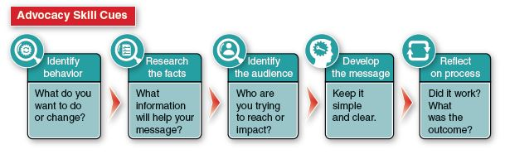
Rating |  | Description
Above Mastery | 4 | Student effectively identifies the behavior or issue, researches the facts needed, clearly identifies and appropriate target audience, develops a clear and simple message and reflects on the outcome and process. The work is of high quality and the overall impact of the work is powerful.
Mastery | 3 | Student identifies the behavior or issue, researches the facts needed, clearly identifies and appropriate target audience, develops a clear and simple message and reflects on the outcome and process. The overall impact of the advocacy work is good.
Approaching Mastery | 2 | Student works through the steps of the skill cue but one or more of the steps is weak and the overall impact of the work is not as strong as it could be.
Novice | 1 | The student fails to work through all steps of the skill cue.

Score: _______________
Comments:

Advocating for Good Health + Content Knowledge
Activity or Task: ______________________________________ Content area: _____________________
Skill Cues: Advocacy
Rating |  | Content Knowledge Description | Rating |  | Setting SMART Goals Description
Above Mastery | 4 | Identifies and utilizes ample, accurate and specific information and could clearly, accurately and appropriately connect the content to all aspects of the skill cue. | Above Mastery | 4 | Student effectively identifies the behavior or issue, researches the facts needed, clearly identifies and appropriate target audience, develops a clear and simple message and reflects on the outcome and process. The work is of high quality and the overall impact of the work is powerful.
Mastery | 3 | Identifies and utilized sufficient information and could clearly, accurately and appropriately connect content to all aspects of the skill cue. | Mastery | 3 | Student identifies the behavior or issue, researches the facts needed, clearly identifies and appropriate target audience, develops a clear and simple message and reflects on the outcome and process. The overall impact of the advocacy work is good.
Approaching Mastery | 2 | Identifies and utilized general information but Sources may be inaccurate or flawed. Student was unable to accurately connect the content to all aspects of the skill cue. | Approaching Mastery | 2 | Student works through the steps of the skill cue but one or more of the steps is weak and the overall impact of the work is not as strong as it could be.
Novice | 1 | No content was identified, or the information is inappropriate to the task. Quality of the information may be poor and/or student is unable to accurately connect the information to the skill cue. | Novice | 1 | The student fails to work through all steps of the skill cue.

Score: _______________
Comment

